OUR SERVICES>CAD Design>PV Design
COMPREHENSIVE SOLUTION FOR SOLAR PV DESIGN
- Introduction
DIGITAL NEST SOLUTIONS is the sole foremost PV Design provider in India
our highly - skilled Designers work across all types of Solar PV installation Design requirements to streamline businesses.
Having a Team of 50+ Proficient and Specialized PV Designers, We bring out superior grade PV Design Services by working around the clock to satisfy the requirements of clients worldwide

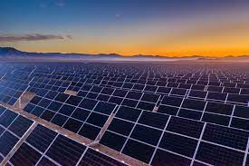

- DNS – Expertise/Competence
a. Residential Design
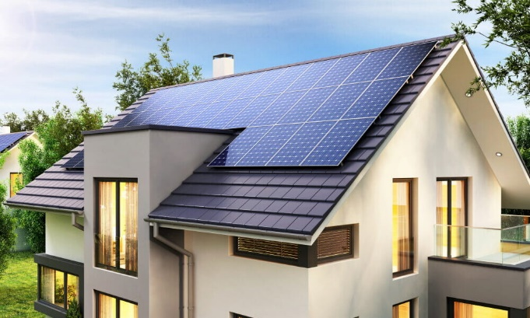
We have extensive experience in designing of residential solar system. We provide variety of services in this sector ranging from sales to interconnection. Our team has in depth knowledge of AHJ and Utility requirements and are acquainted with various codes and compliances.
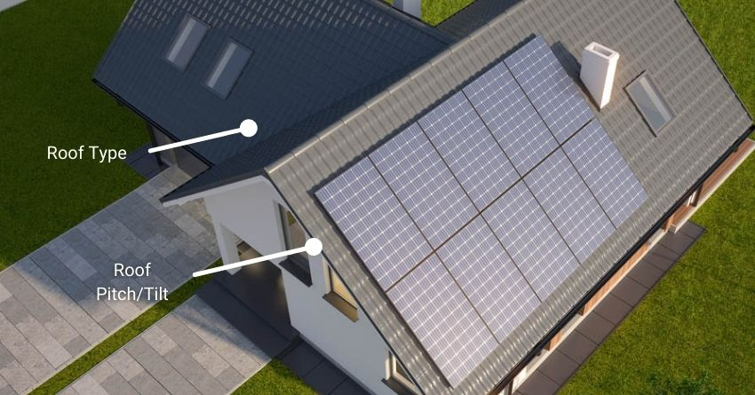

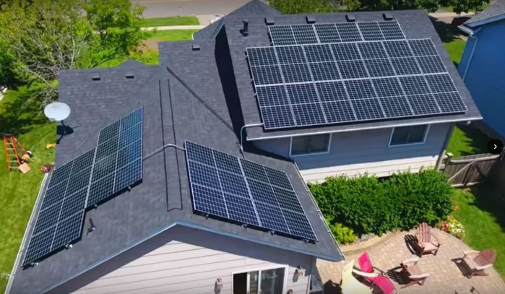

b. Commercial Design
Our Engineering Team is experienced in designing systems for this sector ranging from 20kW to several hundred kW. To ensure compliance with the codes, we provide detailed commercial design assets. As we have experience paired inverter/module, roof/racking, as well as specific incentive schemes to match the system size, we can assist you in choosing the right equipment for Balance of System based on the site specifics, including wind/snow, and general climate characteristics.
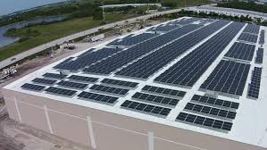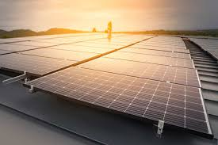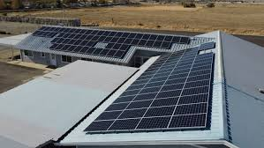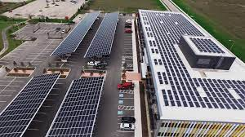
c. Utility Scale Design
The Engineering Services team has a wealth of experience and expertise in dealing with a variety of complex design considerations and variables. A variety of services is available to assist you, from selecting the site and equipment to designing the facility.


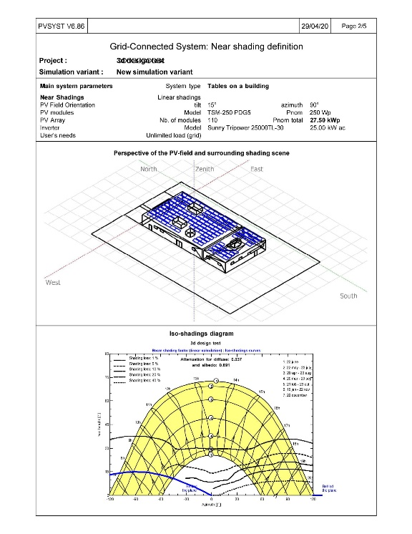
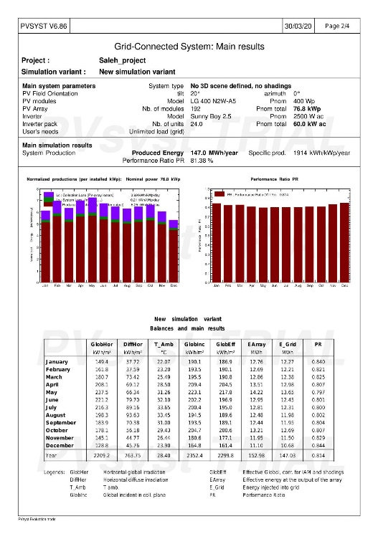
d. Preliminary Design
Preliminary design provides to have a look on the roof design to end user along with pricing, which helps in the conversion of query to an order.
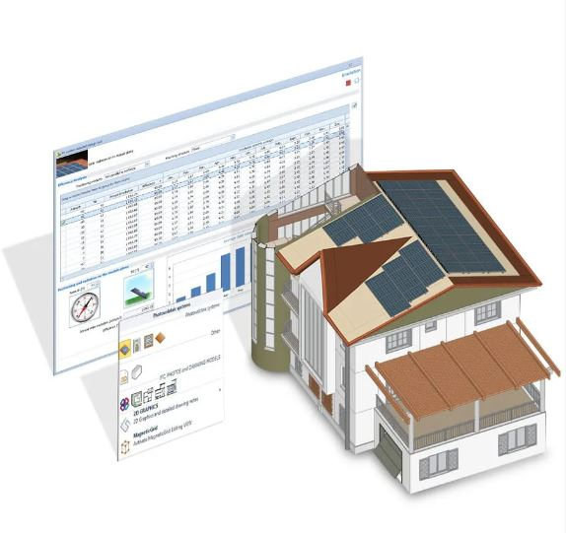
e. PV Syst Simulation
PVsyst is the most powerful software for photovoltaic systems, used for complete PV system survey, dimensioning, simulation and data analysis. PVsyst tools help with pre-planning, quick production estimates for early installation studies, project planning, detailed studies, sizing and hourly simulations. This is the format for full reports, specific charts and tables, and data exports. The tool's advanced features include weather and component database management, specific teaching tools, and the import of measurements for close comparison with simulations.
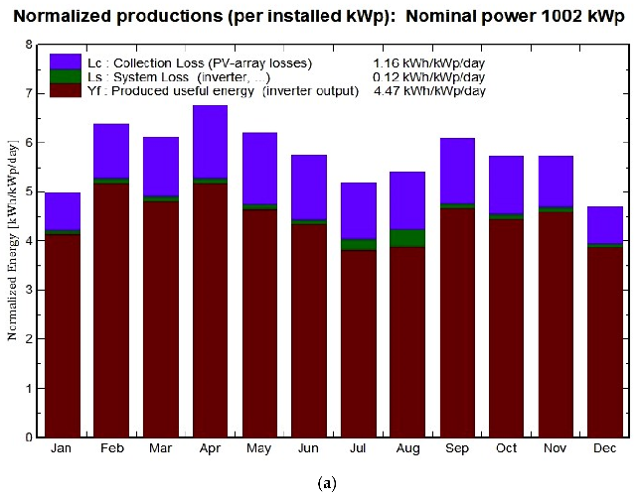
f. Solar Aurora
Solar Aurora is the most used tool for designing a solar power system. Save time and money in the quoting process by creating highly accurate solar designs without visiting the site. Our Team expert can create a design in minimal amount of time.
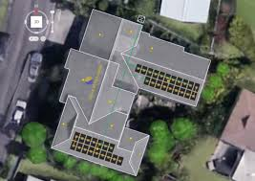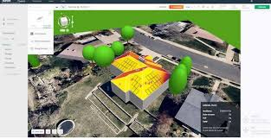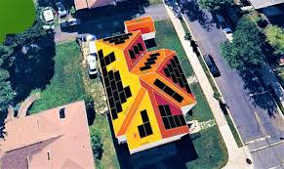
g. HelioScope
HelioScope is the most utilizing tool to design for commercial and utility scale solar projects Which produces high accuracy designs and simulations for respective area by considering atmospheric changes.
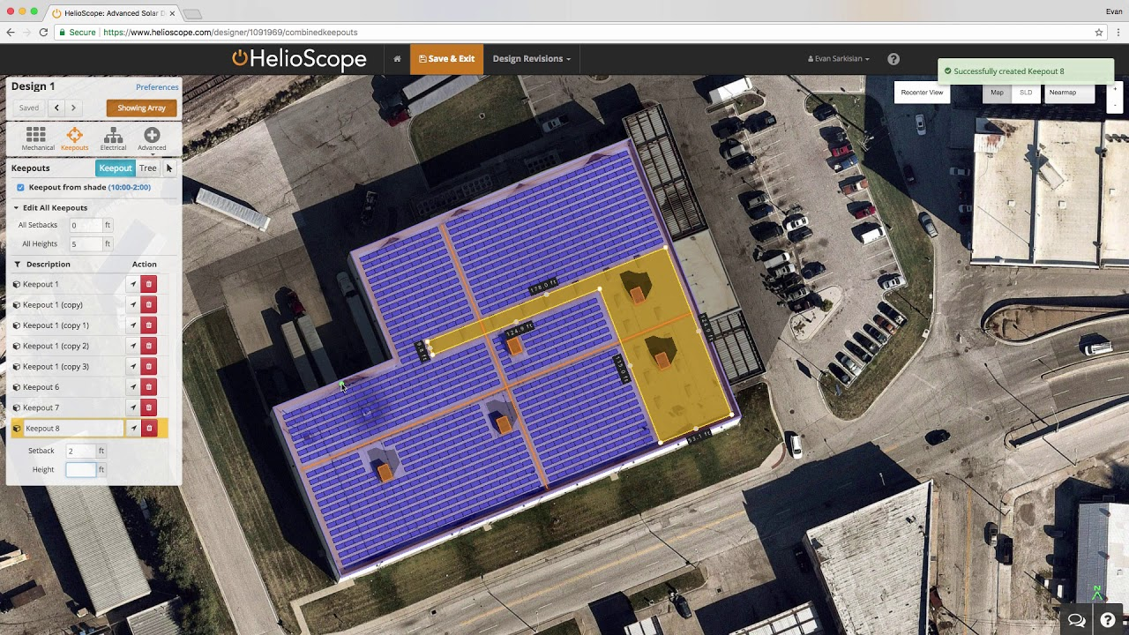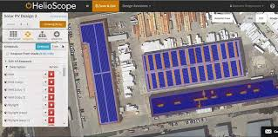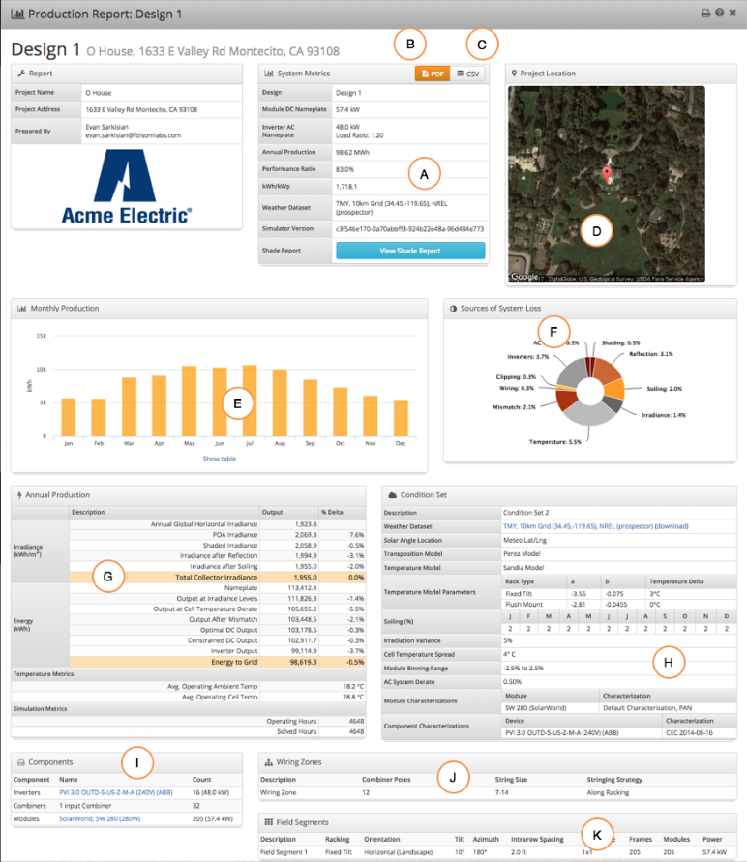
What we have done so far
Provided 10k Plus Solar PV Designs across the world
(Include Image)
Where we serve
Across the world

Last Column
We are Top Designers
We are here to boost your design speed with superior quality of design along with perfect technical specifications
We are friendly
Our Blessed creativity and knowledge on PV design makes us to work whole heartedly
Putting mind and soul into every projects. Client satisfaction is our main motto
We are Achievers
Every Project is kind of mind blowing challenge for the designers, Our good value for service and design results made us the one of the Top PV designers

